Display Deadline
This is where you can decide whether or not you want to display a deadline on the clock window.
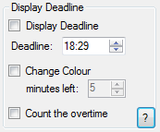
Base Description
If enabled, it is visually represented based on what clock type you have chosen:
- If it’s one of the two digital clocks; the deadline is being displayed underneath the clock itself.
- If it is the analogue clock, the deadline will take shape as two additional hands (hour and minute).
The colour of the deadline text or hands can be altered upon through the advanced options.

Display Deadline
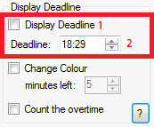
- Checking this box will display the deadline on the clock window. The way it is being represented is based on what clock type you're using.
- This is the deadline value that is being displayed. The start value of this is always the current time in which the program was turned on. This value can be updated live as the clock is being displayed.
Based on the clock type, the Deadline value input will change between going up to 24 hours and 12 hours (which will also display an am/pm label).

Change Colour
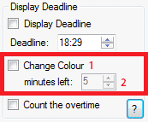
- Checking this box will change the colour of the Deadline when there is an x amount of minutes until the clock hits the deadline. This colour can be changed in the advanced options.
- This is the minute value you set. If you set it to, say, 5 minutes, the colour will change when there is 5 minutes until you hit the deadline. For example, if the time is 01:55, and the deadline is set to be 02:00, the colour will change, because there are 5 minutes until it hits the deadline. This value can be updated live as the clock is being displayed.

Count the overtime
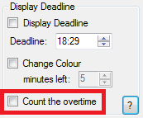
This will yet again change the colour of the deadline, only, this colour will be set if the time has gone beyond the deadline. This colour can be set in the advanced options.
This is also being updated live, so it will take effect as the clock is being displayed on the window.

